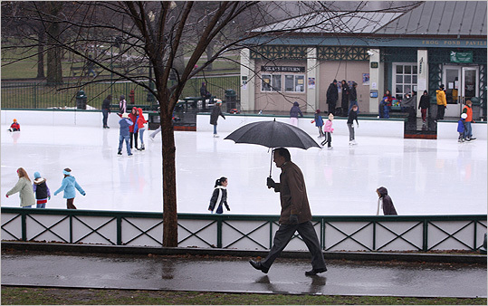

6:00 Executive Session – Grievance Hearing

7:00 Open
Call to Order
7:30 Citizen Comments
Approval of Minutes
Appointments

7:30 George Davis – Energy Committee Interview

7:35 Beautification Committee Awards

7:50 Conservation Commission Update

8:00 School Committee Update

Old Business

- Goals & Policies

New Business

- One Day License Request – Silent Chef, 2/1/13

- Open Warrant
Upcoming Meetings
Announcements
Adjournment
Executive Session – Personnel Contracts and Security

